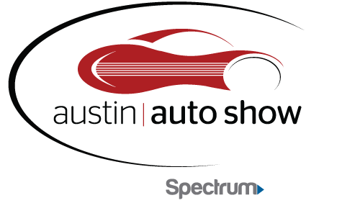

April 20 – 22, 2018
Austin Convention Center
MEDIA CREDENTIAL APPLICATION

Please complete the information below to be considered for the Austin Auto Show credentials. All requests must be received by Wednesday, April 18th. Please e-mail this form to Samantha Crist at samantha.crist@charter.com .

Name:

Organization:

Address:

Phone:

Email Address:

Website:

Date you will be attending the Show:

Please circle the medium that best describes your organization:

Television Radio Newspaper Online Other

Please list below the name(s) of your organization representative(s) and title(s) who will need Media Credentials:

1.

2.

823 Congress Ave. • Suite 230 • Austin, TX 78701 • (512) 645-3453

