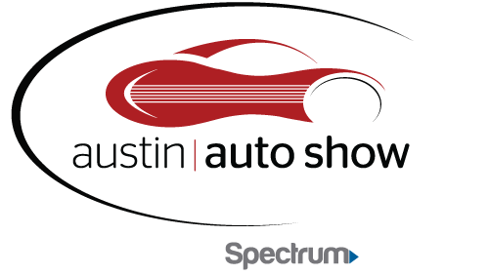

Austin Convention Center
MEDIA CREDENTIAL APPLICATION

Please complete the information below to be considered for the Austin Auto Show credentials. All requests must be received by Wednesday, April 18th. Please e-mail this form to Mario Portillo at Mario.Portillo@charter.com .

Name:

Organization:

Address:

Phone:

Email Address:

Website:

Date you will be attending the Show:

Please circle the medium that best describes your organization:

Television Radio Newspaper Online Other

Please list below the name(s) of your organization representative(s) and title(s) who will need Media Credentials:

1.

2.

823 Congress Ave. • Suite 230 • Austin, TX 78701 • (512) 645-3453

